Lab 4A – Configure Static Routing

**Static Routing**

|  |  |  |  |  |
| --- | --- | --- | --- | --- |
| Device | Interface | IP address | Subnet Mask | Default Gateway |
| R1 | S0/2/0 | 192.168.10.1 | 255.255.255.0 | N/A |
| F0/0 | 192.168.110.1 | 255.255.255.0 | N/A |
| R2 | S0/2/0 | 192.168.10.2 | 255.255.255.0 | N/A |
| S0/2/1 | 192.168.20.1 | 255.255.255.0 | N/A |
| F0/0 | 192.168.30.1 | 255.255.255.0 | N/A |
| R3 | S0/2/0 | 192.168.20.2 | 255.255.255.0 | N/A |
|  | F0/0 | 192.168.120.1 | 255.255.255.0 | N/A |
| PC1 | NIC | 192.168.110.2 | 255.255.255.0 | 192.168.110.1 |
| PC2 | NIC | 192.168.30.2 | 255.255.255.0 | 192.168.30.1 |
| PC3 | NIC | 192.168.120.2 | 255.255.255.0 | 192.168.120.1 |

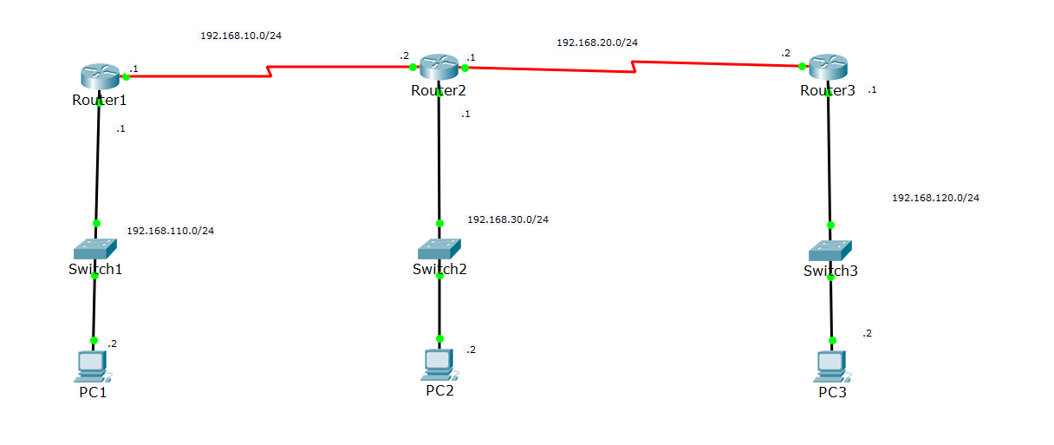

**Learning Objectives**

* Describe the function of the routing table
* Describe how a routing table can contain and use static routes

### Introduction:

Routers can learn of remote networks via static or dynamic routing. This activity focuses on how remote networks are added to the routing table using static routes. This is one of two ways that a remote network can be added to the routing table. Static routes are configured by the network administrator and include the network address and subnet mask of the remote network, along with the IP address of the next-hop router or the exit interface of the local router.

**TASK 1: Configure Static route on R1 – 12.5 points**

Enter a static route on R1 to reach R2's and R3’s LAN. All of the interfaces on the router are configured and are functional. However, it is not possible to reach R2's and R3’s LAN from R1. Follow the steps below to enter a static route on R1 to reach R2's and R3’s LAN:

**Step 1: configure static route on R1 to reach R2’s LAN**

* Click on R1 in the workspace.  Select the CLI tab.
* At the R1> prompt, issue the **enable** command. The prompt changes to R1#, indicating that the router is now in privileged mode.
* Enter the command R1# **configure terminal**to change to Global Configuration Mode.
* Enter the static route R1(config)# **ip route 192.168.30.0 255.255.255.0 s0/2/0**
* Exit Global Configuration Mode R1(config)# **end**

**Step 2: configure static route on R1 to reach R3’s LAN**

* Click on R1 in the workspace.  Select the CLI tab.
* At the R1> prompt, issue the **enable** command. The prompt changes to R1#, indicating that the router is now in privileged mode.
* Enter the command R1# **configure terminal**to change to Global Configuration Mode.
* Enter the static route R1(config)# **ip route 192.168.120.0 255.255.255.0 s0/2/0**
* Exit Global Configuration Mode R1(config)# **end**

**Step 3: configure static route on R1 to reach R3**

* Click on R1 in the workspace.  Select the CLI tab.
* At the R1> prompt, issue the **enable** command. The prompt changes to R1#, indicating that the router is now in privileged mode.
* Enter the command R1# **configure terminal**to change to Global Configuration Mode.
* Enter the static route R1(config)# **ip route 192.168.20.0 255.255.255.0 s0/2/0**
* Exit Global Configuration Mode R1(config)# **end**

**Step 4: Examine the routing table on R1.**

* From the command line interface (CLI) type R1#**show ip route**

**TASK 2: Configure Static route on R2 – 12.5 points**

**Step 1: configure static route on R2 to reach R1’s LAN**

* Click on R2 in the workspace.  Select the CLI tab.
* At the R2> prompt, issue the **enable** command. The prompt changes to R2#, indicating that the router is now in privileged mode.
* Enter the command R2# **configure terminal**to change to Global Configuration Mode.
* Enter the static route R2(config)# **ip route 192.168.110.0 255.255.255.0 s0/2/0**
* Exit Global Configuration Mode R2(config)# **end**

**Step 2: configure static route on R2 to reach R3’s LAN**

* Click on R2 in the workspace.  Select the CLI tab.
* At the R2> prompt, issue the **enable** command. The prompt changes to R2#, indicating that the router is now in privileged mode.
* Enter the command R2# **configure terminal**to change to Global Configuration Mode.
* Enter the static route R2(config)# **ip route 192.168.120.0 255.255.255.0 s0/2/1**
* Exit Global Configuration Mode R2(config)# **end**

**Step 3: Examine the routing table on R2.**

* From the command line interface (CLI) type R2#**show ip route**

**TASK 3: Configure Static route on R3 – 12.5 points**

**Step 1: configure static route on R3 to reach R1’s LAN**

* Click on R3 in the workspace.  Select the CLI tab.
* At the R3> prompt, issue the **enable** command. The prompt changes to R3#, indicating that the router is now in privileged mode.
* Enter the command R3# **configure terminal**to change to Global Configuration Mode.
* Enter the static route R3(config)# **ip route 192.168.110.0 255.255.255.0 s0/2/0**
* Exit Global Configuration Mode R3(config)# **end**

**Step 2: configure static route on R3 to reach R2’s LAN**

* Click on R3 in the workspace.  Select the CLI tab.
* At the R3> prompt, issue the **enable** command. The prompt changes to R3#, indicating that the router is now in privileged mode.
* Enter the command R3# **configure terminal**to change to Global Configuration Mode.
* Enter the static route R3(config)# **ip route 192.168.30.0 255.255.255.0 s0/2/0**
* Exit Global Configuration Mode R3(config)# **end**

**Step 3: configure static route on R3 to reach R1**

* Click on R3 in the workspace.  Select the CLI tab.
* At the R3> prompt, issue the **enable** command. The prompt changes to R3#, indicating that the router is now in privileged mode.
* Enter the command R3# **configure terminal**to change to Global Configuration Mode.
* Enter the static route R3(config)# **ip route 192.168.10.0 255.255.255.0 s0/2/0**
* Exit Global Configuration Mode R3(config)# **end**

**Step 4: Examine the routing table on R3**

* From the command line interface (CLI) type R3#**show ip route**

**TASK 4: Check the connectivity – 12.5 points**

|  |  |  |
| --- | --- | --- |
| From | To | Yes/No |
| PC1 | PC2 |  |
| PC2 | PC3 |  |
| PC3 | PC1 |  |
|  |  |  |

**Lab 4B: Propagating the Default Route In RIP**

|  |  |  |  |  |
| --- | --- | --- | --- | --- |
| **Device** | **Interface** | **IP Address** | **Subnet Mask** | **Default Gateway** |
| R1 | **F0/0** | **10.10.1.1** | **255.255.255.0** | **N/A** |
|  | **S0/0/0** | **10.10.2.1** | **255.255.255.0** | **N/A** |
| **R2** | **F0/0** | **10.10.3.1** | **255.255.255.0** | **N/A** |
|  | **S0/0/0** | **10.10.2.2** | **255.255.255.0** | **N/A** |
|  | **S0/0/1** | **172.30.1.1** | **255.255.255.252** | **N/A** |
| **R3** | **S0/0/0** | **172.30.1.2** | **255.255.255.252** | **N/A** |
|  | **F0/0** | **192.168.4.1** | **255.255.255.0** | **N/A** |
| **PC1** | **NIC** | **10.10.1.2** | **255.255.255.0** | **10.10.1.1** |
| **PC2** | **NIC** | **10.10.3.2** | **255.255.255.0** | **10.10.3.1** |
| **PC3** | **NIC** | **192.168.4.2** | **255.255.255.0** | **192.168.4.1** |

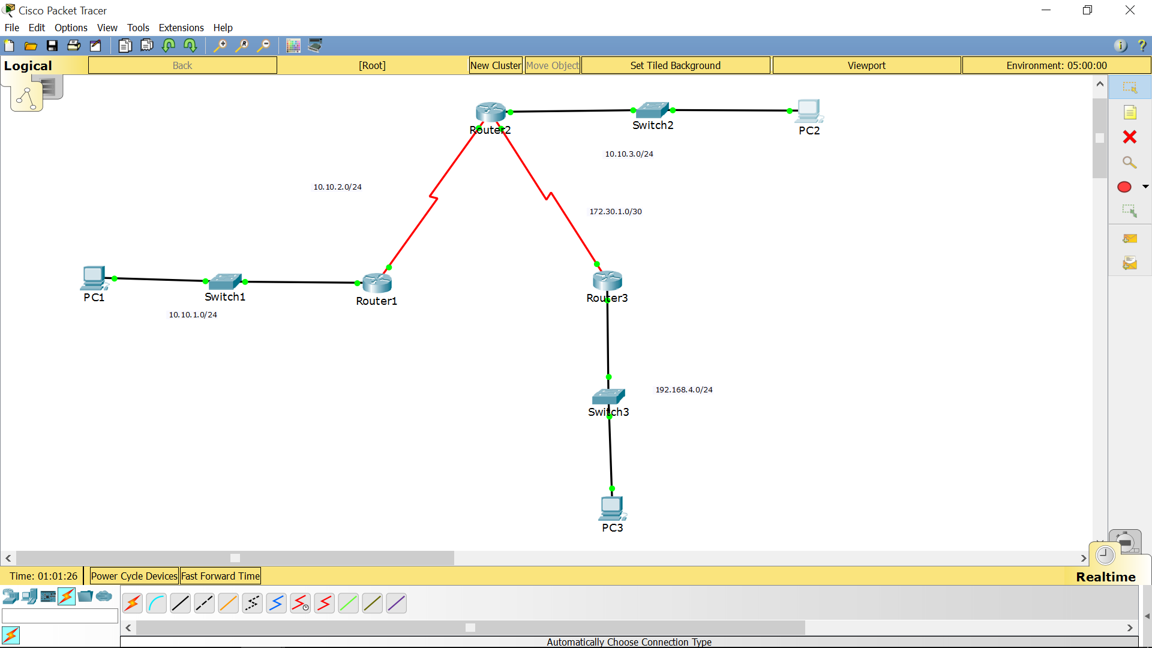

**Introduction:**

In today’s networks, customers rarely, if ever, exchange routing updates with their ISP. Customer routers that connect to an ISP do not need a listing for every route on the Internet. Instead, these routers have a default route that sends all traffic to the ISP router when the customer router does not have a route to a destination. The ISP configures a static route pointing to the customer router for addresses inside the customer’s network. In this activity R3 will represent the router for the ISP, R2 will represent the border router that connects to the ISP, and R1 will represent an internal router within the organization.

### Learning Objectives:

* Reconfigure R2 and R3 for default and static routing.
* On R2, remove the network to R3 from RIP and configure a default route.
* On R3, remove RIP and configure a static route.
* Reset the network and view the results.
* Propagate the default route in RIP.
* Configure R2 to propagate the default route in RIP.
* Examine RIP updates.
* Examine the IP routing table on R1.
* Check connectivity.

### Task 1: Reconfigure routers R2 and R3 for default and static routing. – 25 points

#### Step 1 – On R2, remove the network to R3 from RIP and configure a default route.

* Access Router R2 and enter privileged exec mode. Enter the global configuration mode. Enter the router configuration mode by issuing the command **router rip**.
* Issue the command **no network 172.30.1.0** and Issue the command **exit** to return to global configuration mode.
* Issue the command **ip route 0.0.0.0 0.0.0.0 s0/0/1**.
* Exit the configuration mode by using **Ctrl+z**. Save the configuration by issuing the command **copy run start**.

#### Step 2 – On R3, remove RIP and configure a static route.

* Access Router R3 and enter privileged exec mode. Enter the global configuration mode.
* Issue the command **no router rip**.
* Issue the command **ip route 10.10.0.0 255.255.252.0 s0/0/0**.
* Exit the configuration mode by using **Ctrl+z**. Save the configuration by issuing the command **copy run start**.

#### Step 3 – Reset the network

* Click the **Power Cycle Devices** link below the lower left corner of the Logical Workspace to reset the network and update the routing tables.

### Task 2: Propagate the default route in RIP. – 25points

#### Step 1 – Configure R2 to propagate the default route in RIP.

* Access Router R2 and enter privileged exec mode. Enter the global configuration mode. Enter the router configuration mode by issuing the command **router rip**.
* Issue the command **default-information originate**.
* Exit configuration mode by hitting **Ctrl+z**. Save the configuration by issuing the command **copy run start**.

#### Step 2 – Examine RIP updates.

On Router R2, examine RIP updates by issuing the command **debug ip rip**. Allow the command to run for several minutes and observe the updates that are sent and received. Issue the command **undebug all**.

#### Step 3 - Examine the IP routing table on R1.

On Router R1, examine the IP routing table by issuing the command **show ip route**. On Router R1 a default route has been learned from RIP updates.

#### Step 4 - Check connectivity.

Verify full connectivity by pinging from each PC to the other two PCs. All pings should succeed.